Rede Social  
**Planejamento técnico**

short line

# Mapeamento das actions do APP

* Users
  + Devise
  + profile
  + followers
  + following
  + search
* Post
  + index
  + create
  + destroy
  + edit
  + update
* Comment
  + create
  + destroy
  + edit
  + update
* Like
  + create
  + destroy
* Follow
  + create
  + destroy
* Group
  + new
  + create
  + show
  + members
  + search
  + destroy
* GroupUsers
  + create
  + destroy
* Notification
  + create

# Criação dos Wireframes

Home

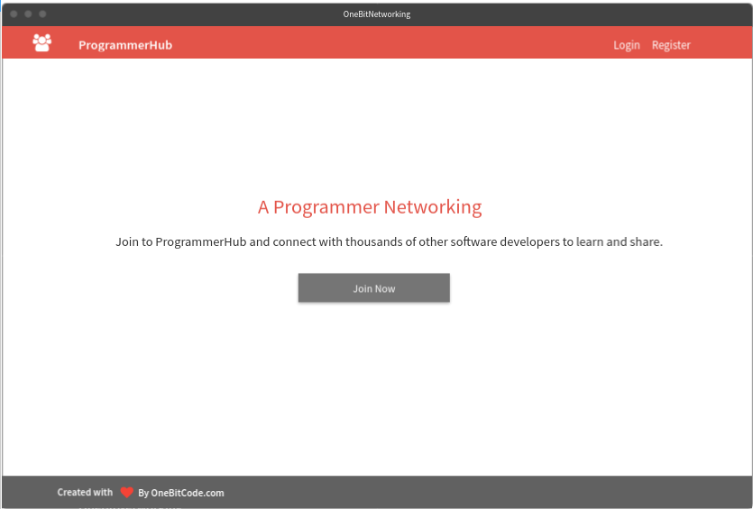

Profile

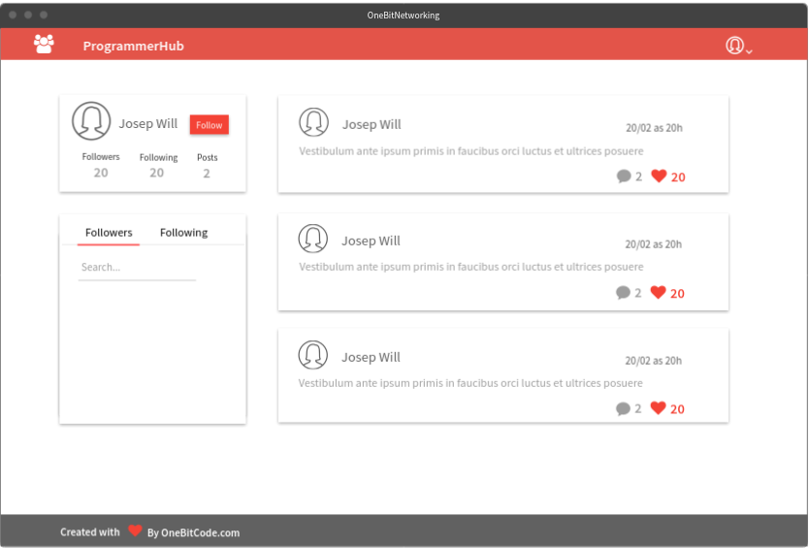

Posts

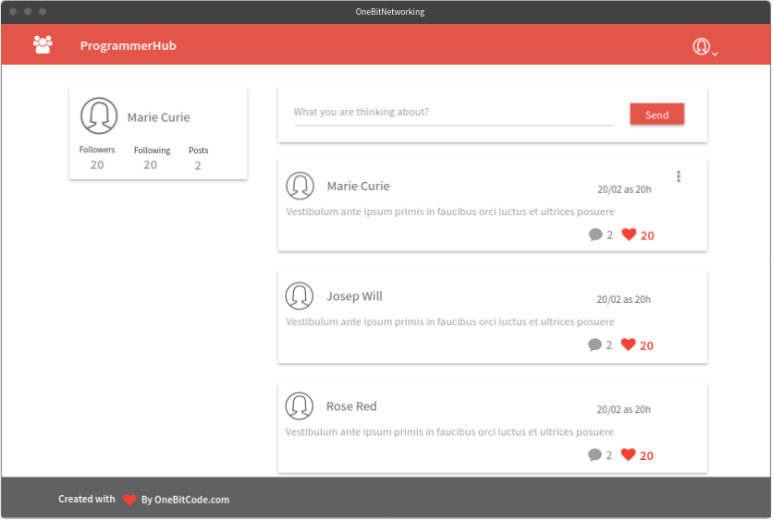

Followers/Followings/Search

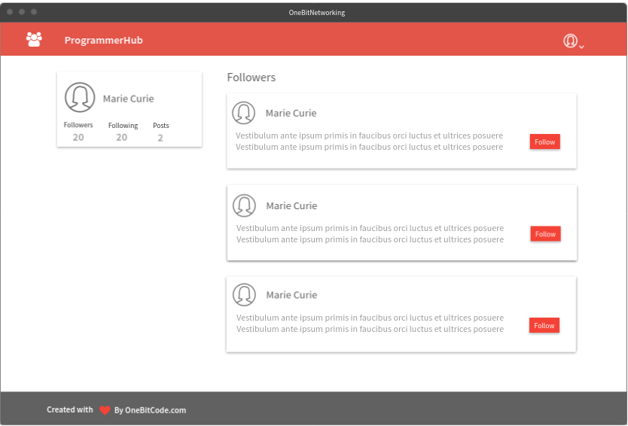

# Modelagem do Banco de dados

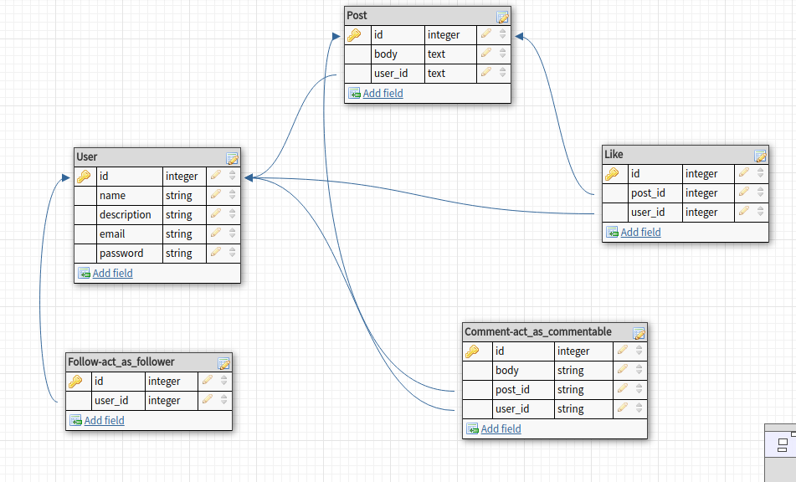

# Stack do Projeto

* Desenvolvimento
  + Ruby on Rails
  + PostgreSQL
  + Imagemagick

Bibliotecas(gems):

* + - devise
    - cancancan
    - mini_magick
    - carrierwave
    - materialize
    - toast materialize
    - ransack
    - better errors